Nepal College of Information Technology
Assessment
Fall 2011
Program : BE IT Time : 3 hrs
Semester : Fall (III) FM : 100
Subject : Electronic Circuits-I PM : 50

- Candidates are requested to give their answer as far as practicable in their own words.
- The figure in the margin indicates the full marks
- Attempt ALL question

1. a. What is push pull amplifier? Explain complementary symmetry push pull amplifier? Find the power conversion efficiency of class B operation. [7]
b. In the Class A amplifier shown below, Find [8]
i) the quiescent power dissipation of transistor
ii) the maximum possible peak output voltage
iii) the average power from dc power supply
iv) average power deliver to load.
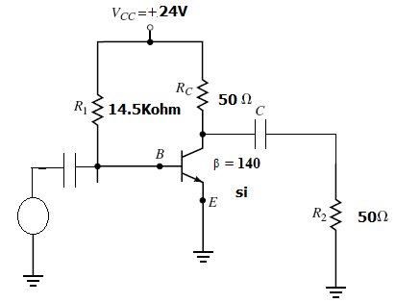
2. a. What are the advantages and disadvantages of negative feedback? Explain its role on gain stability and bandwidth extension. [8]
b. An amplifier has midband gain of 125 and a bandwidth of 250KHz [7]
i) if 4% negative feedback is introduced, find the new bandwidth and gain.
ii) if the bandwidth is to be restricted to 1MHz, find the feedback ratio.
3. a. What is Barkhausen Criteria for oscillation? Explain oscillation with positive feedback concept? [7]
b. Explain the circuit operation of Colpitt’s LC oscillator with neat sketch and necessary deductions? [4]
c. The Ac equivalent of crystal oscillator has these values; L = 1H, Cs = 0.01pF, R = 1000Kohm, Cp = 20pF. Calculate fs and fp of the crystal. [4]
4. a. What are the main characteristics of Ideal operational amplifier? Define the terms; Virtual ground, Slew rate, and CMRR. [7]
b. with the help of necessary circuit diagram and derivation, discuss the application of Op-Amp as subtractor and differentiator. [8]
5. a. Explain the working principle of dual slope A/D converter. [8]
b. Explain the working principle of R/2R ladder D/A converter. [7]
6. a. Explain the operation of astable multivibrator circuit with the help of circuit diagram and waveform. [7]
b. Show the maximum possible efficiency of the series fed Class A amplifier is only 25% [8]
7. Write short notes on any two [5×2]
i) Voltage controlled oscillator.
ii) Monostable multivibrator using Op-Amp.
iii) Class AB operation

